TÓRSHAVN BRIDGEFESTIVAL 2020
2nd

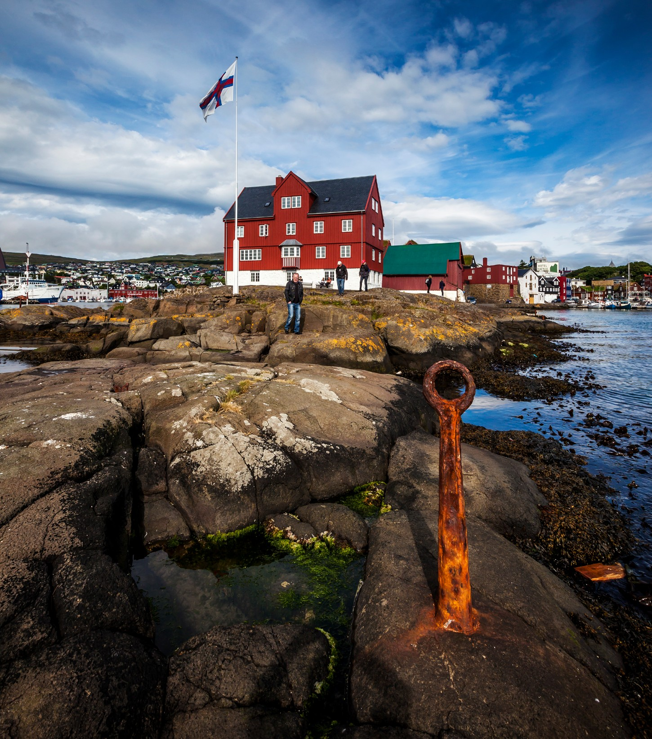

TÓRSHAVN BRIDGE FESTIVAL 6-7 March 2020
According to National Geographic, New York Times and a wide array of other international media, the Faroe Islands is one of those places you just have to visit. Now you have the opportunity to experience the Faroe Islands while living out your passion for bridge. Together with your bridge partner, you may participate in Tórshavn Bridge Festival, an open pairs tournament organized on 6-7 March 2020. Prices start at just *DKK 5.195.

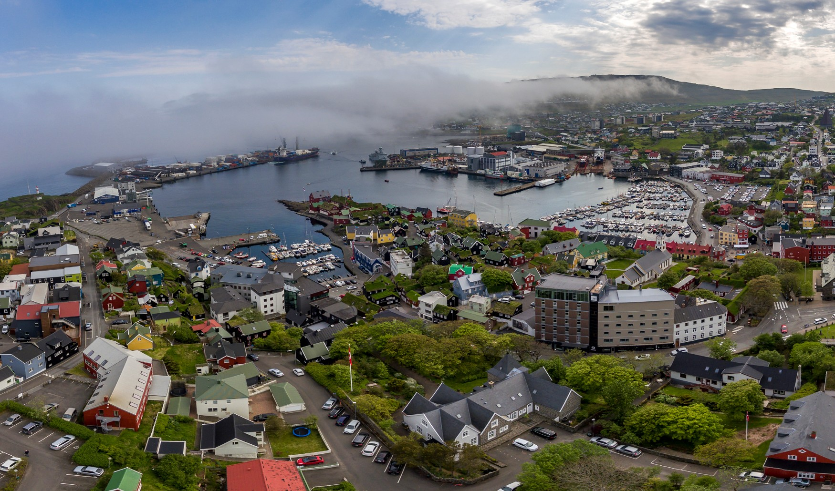

TOURNAMENT FORMAT
The tournament is an open Swiss pairs tournament. The maximum numbers of pairs is 100, the tournament was fully booked in 2019

VENUE
The tournament venue is the four star Hotel Føroyar. www.hotelforoyar.fo

ORGANISER
The Faroese Bridge Association organises the tournament. You can visit the association’s website at www.Bridge.fo

PRIZES
The award for first place is two-times-two flights with Atlantic Airways on their northern routes and 2 nights in a double room at Hotel Føroyar with three-course dinner at Restaurant Gras. The award for second place is a DKK 2,000 gift certificate from Fonnflog travel agency. First, second and third placed pairs all get free attendance at Tórshavn Bridge Festival in 2021.

REGISTRATION
You may register for the tournament via fonnflog@fonnflog.fo. Registration is confirmed once the tournament fee is payed. Please submit both your own name and the name of your partner.

TRAVEL AND COST
We offer package deals that include flights, hotel, airport transfers in the Faroes and the tournament fee, which covers a light meal Friday night, lunch on Saturday and the banquet dinner on Saturday night. During the tournament itself, water, coffee/tea and snacks will be available (free) at the venue. Travelling participants may choose to arrive on Friday and depart Sunday, requiring only two over-night stays. However, the package deals offered assumes three nights with arrival on the 5th or 6th and departure on the 8th or 9th March, providing you with the opportunity to explore Tórshavn and the Faroe Islands on both Thursday and Sunday. It is also possible to buy extra nights at the hotel for those who wish to stay longer. Should you point of departure not be mentioned as a package, please contact the travel agency at fonnflog@fonnflog.fo. Should you wish to only buy the tournament fee, the price is DKK 1.400 pr person

HOTELS
The guest will stay at the Hotel Føroyar. It is also possible to stay at Hotel Tórshavn in the center of Tórshavn. Homepages: (http://hoteltorshavn.fo ) (www.hotelforoyar.fo)

EXCURSION
If you opt to stay until Monday, you may order one out of two possible excursions on Sunday 8th March. One is a bus tour to some of the key sights around the Faroe Islands; the second option is a spectacular mountain hike to the village of Gásadalur. The hike is weather dependent and the route and destination might be changed.
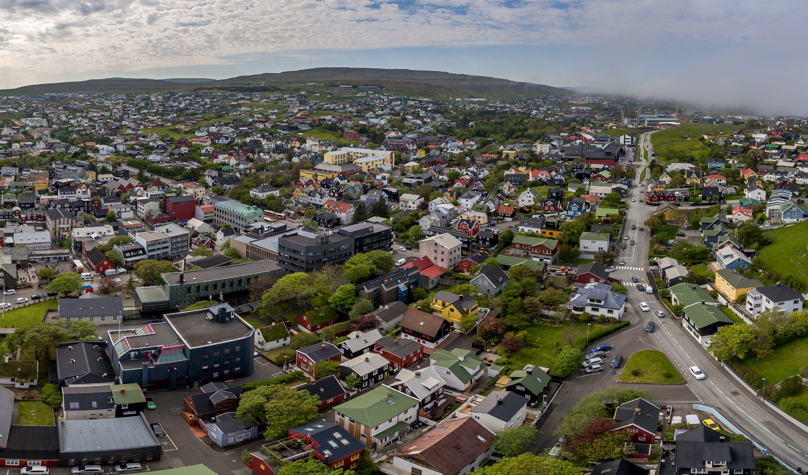
PHOTOGRAPHER: ÓLAVUR FREDERIKSEN

PACKAGE DEALS BY COUNTRY:

DENMARK
Copenhagen – Faroe Islands – Copenhagen:
From *DKK 5,195, – Price includes: flight, 3 nights in shared double room at Hotel Føroyar, airport transfer in the Faroes and tournament fee. Arrival 5 or 6 March – Departure 8 or 9 March.

Billund – Faroe Islands – Billund:

Fra * DKK 5.895. Price includes: flight, 4 nights in shared double room at Hotel Føroyar, airport transfer in the Faroes and tournament fee. Arrival 5 – Departure 9 March.

ICELAND

Keflavík – Faroe Islands – Keflavík:
From *DKK 5,195, – Price includes: flight, 3 nights in shared double room at Hotel Føroyar, airport transfer in the Faroes and tournament fee. Arrival 6 March – Departure 9 March.

NORWAY
Oslo – Faroe Islands – Oslo (Via CPH):
From *DKK 6,250. Price includes: flight, 3 nights in shared double room at Hotel Føroyar, airport transfer in the Faroes and tournament fee. Arrival 5 or 6 March – Departure 8 or 9 March

Bergen – CPH – Faroe Islands - Bergen:
From *DKK 6.350. Price includes flight, 4 nights in shared double room at Hotel Føroyar, airport transfer in the Faroes and tournament fee. Arrival 5 March – Departure 9 March

SWEDEN

Stockholm – Faroe Islands – Stockholm (Via CPH):
From *DKK 6,150, – Price includes: flight, 3 nights in shared double room at Hotel Føroyar, airport transfer in the Faroes and tournament fee. Arrival 5 or 6 March – Departure 8 or 9 March.

FINLAND

Helsinki – Faroe Islands – Helsinki (Via CPH):
From *DKK 6.350, – Price includes: flight, 3 nights in shared double room at Hotel Føroyar, airport transfer in the Faroes and tournament fee. Arrival 5 or 6 March – Departure 8 or 9 March.
*All prices are subject to availability, and sold out dates.
For other travel options, please contact our travel agency Fonnflog at fonnflog@fonnflog.fo

